**GatorBall Design Draft**

**Introduction** - project value

* Purpose/Need - Describe the purpose in society for the project you are designing. Specifically, explain why it is needed, by whom, and in what context. Identify how the project is useful and goes beyond a mere demonstration.
  + **This product is intended for football enthusiasts to accurately track first-downs without the need for a referee. It is needed because having a referee step out onto the field to manually measure the football and determine if a first-down has been established greatly slows down the momentum of the game and is also cumbersome to do. Our product will resolve this issue by providing an effortless way of tracking first-downs without the need for any human intervention. This product is primarily intended for small-scale football games like flag football or, potentially, intramural-level games.**
* Augustus - Domain & Prior Art - Explain the field / area of the project and describe existing work in this area. Provide examples from existing commercial products, web searches, or articles appearing in the literature. All examples should be cited. Identify what features will differentiate your solution from others and why your project will make a difference.
  + **Existing work similar to our product is used heavily in the NFL [1]. The NFL embeds RFID tags in player uniforms as well as the football itself. These RFID tags are extremely lightweight and unobtrusive, so they have a negligible impact on gameplay. The data collected by these tags allows the NFL to track statistics such as ball height, position, velocity, as well as player speed, passing rates and much more. These statistics greatly enhance the game and allow for the NFL as well as enthusiasts to deep-dive into player stats. Our product, on the other hand, will focus specifically on the ball position to allow us to determine if a first-down has been made.**
* Tyler - Impact & Risk Assessment - societal impact (culture, global, economic, environmental and social), ethical context and potential risks

**Joshua - Statement of Work** - work to be done during semester

**Deliverable Artifact**s - what will be delivered at the end of the project? Hardware, software, and documentation

* A short description of the artifact – how does it fit into the project as a whole?
  + **At the end of the project, our team will deliver a package composed of a few different artifacts. The hardware we will deliver at the end of the project will be a microprocessor that continuously collects positional data (and potentially velocity and rotational inertia) from a RFID tag. The software we will deliver will include the code we use to accomplish this. Finally, we will deliver user-friendly documentation that outlines how to set up and use the product.**
* For software/documentation, dissemination plan: format and distribution of project
* Joshua | Accessibility/Usability/Maintenance Plan - how will the project remain useful long term?

**Mockups** - visual models; wireframes, draft schematics, and other diagrams

* Interfaces - parts of project with human interaction | Ricardo
* Tyler - Systems - how systems communicate with each other (hardware and software)
* Augustus - Networking - any type of telecommunication; application
* Storyboards - mockup of each software screen | Ricardo
* Andrew - Draft Schematics - draft model for schematics; major components, what they do and how they connect

This is the first draft of the draft schematics still need to add text

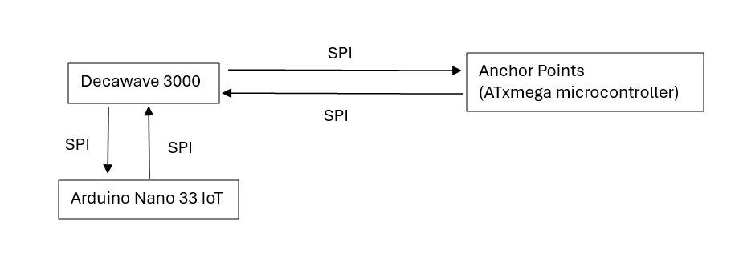

**Sources:**

**[1]** [**https://www.engineering.com/the-technology-behind-the-nfls-incredibly-precise-stats/**](https://www.engineering.com/the-technology-behind-the-nfls-incredibly-precise-stats/)